**Initialize a Volume Restored from a Snapshot on Linux**

* **Selecting the snapshot**
* Go to EC2 dashboard in EBS and click on Snapshot

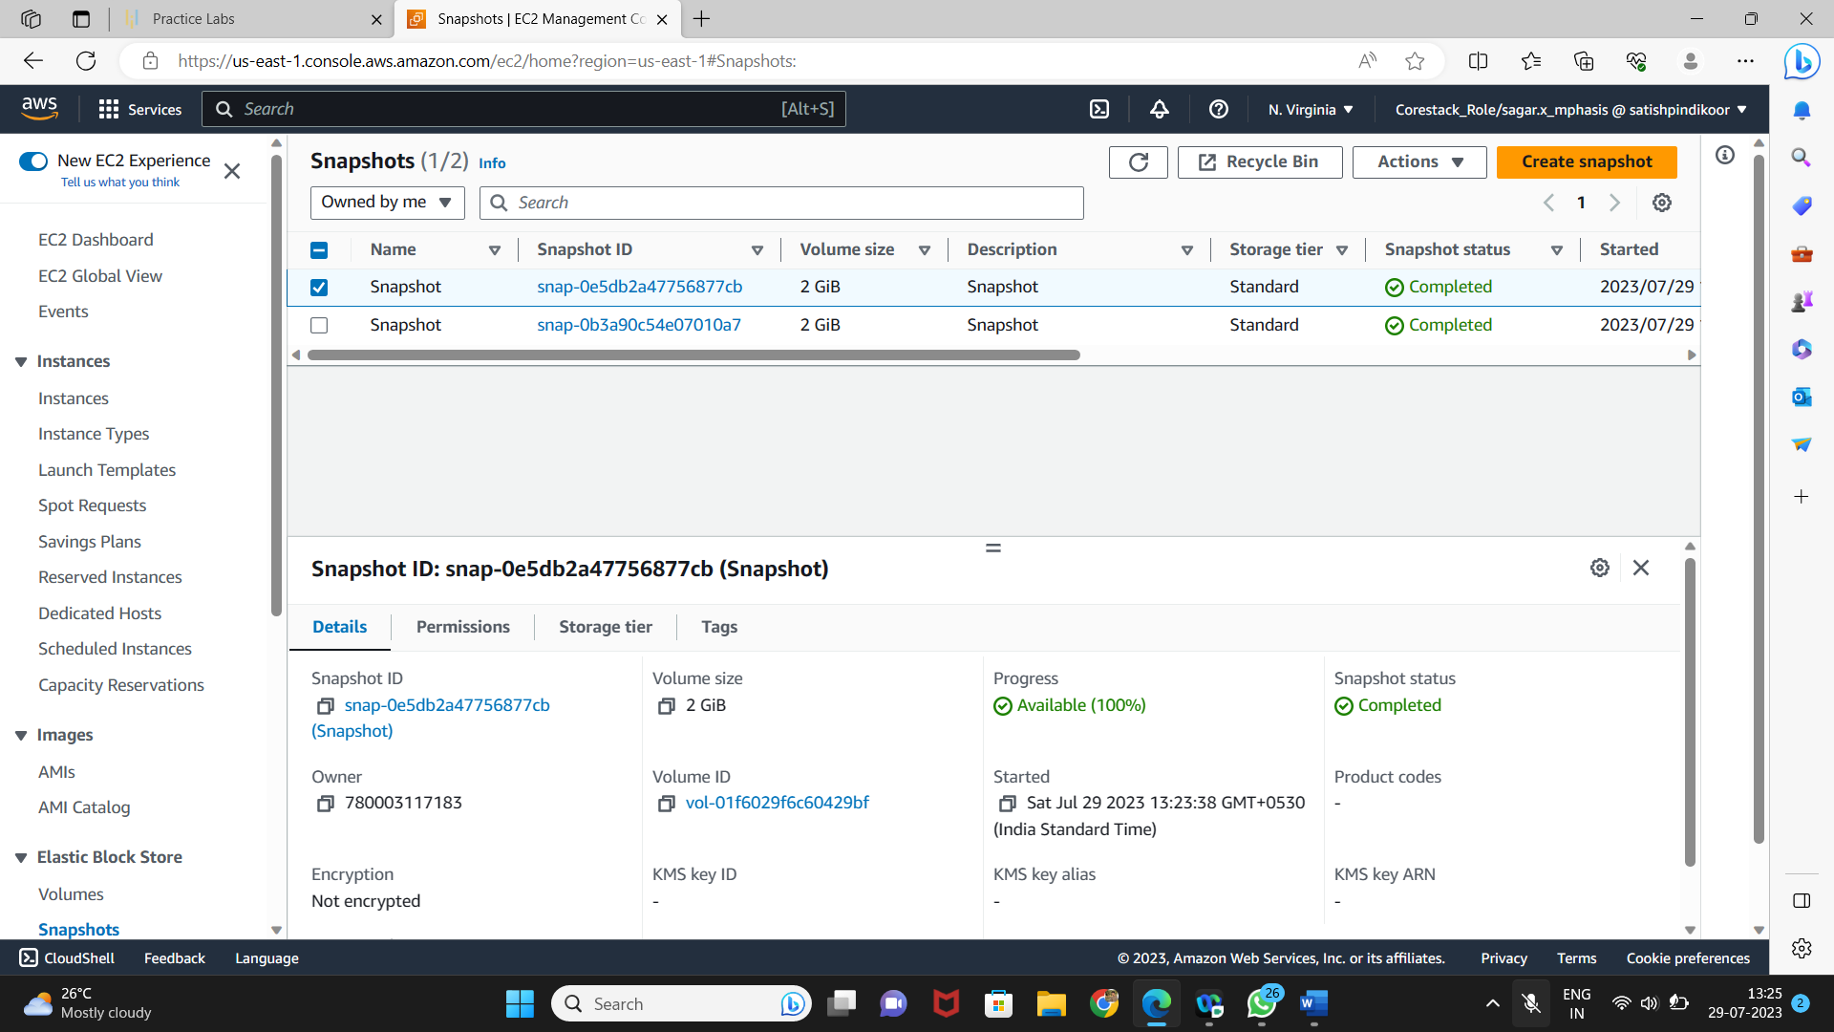

* **Restoring volume from the snapshot**
* Select the snapshot and click on Action

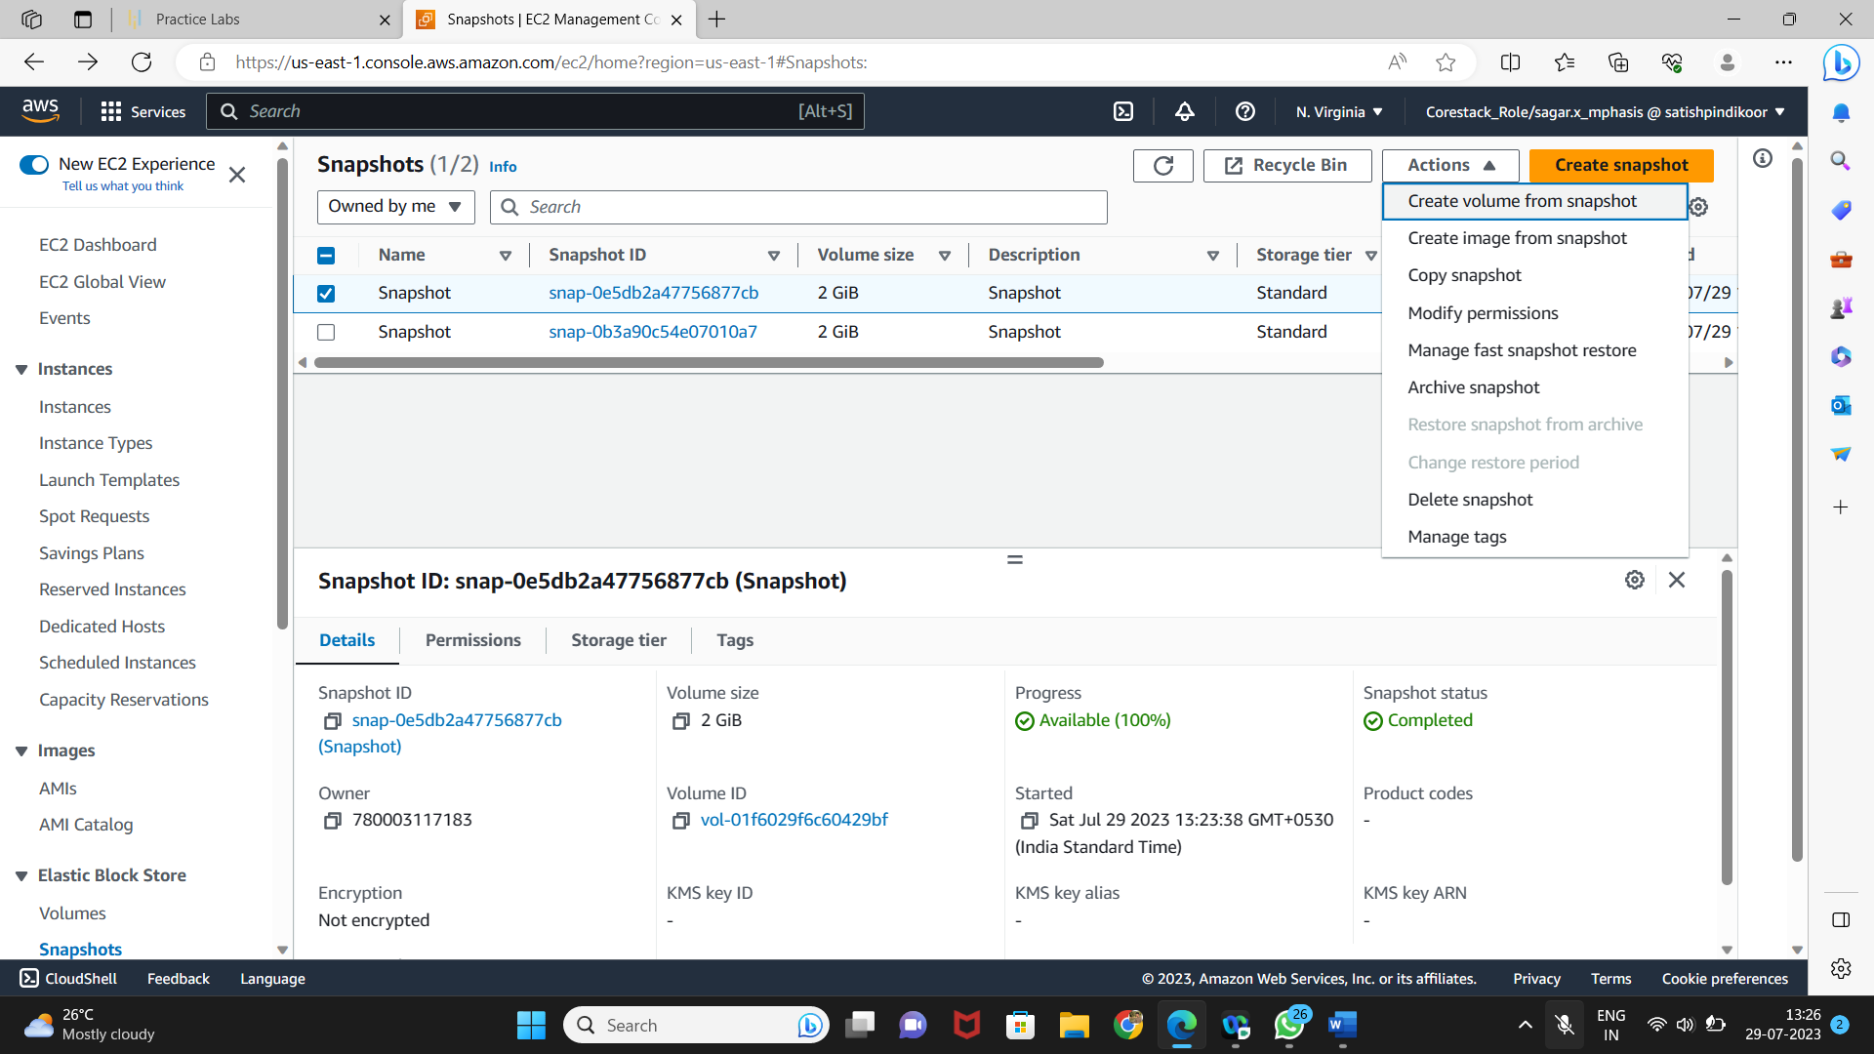

* You can specify the key and value to identify the volume

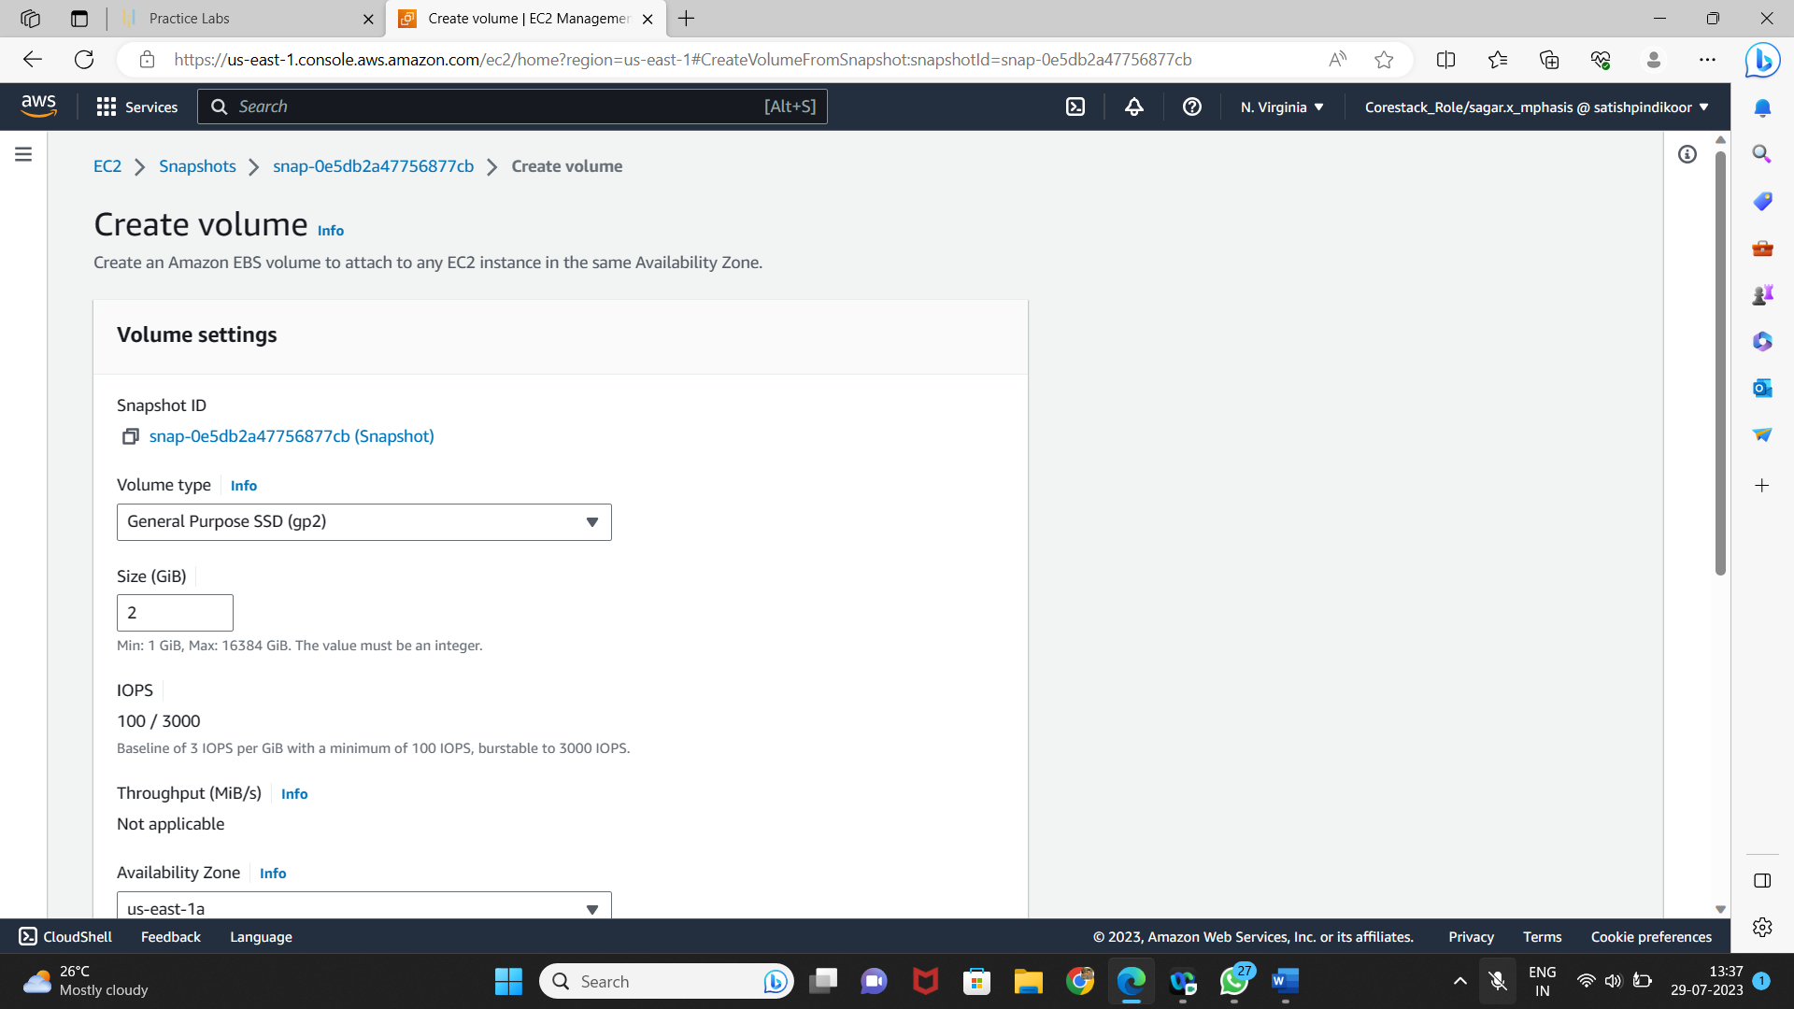

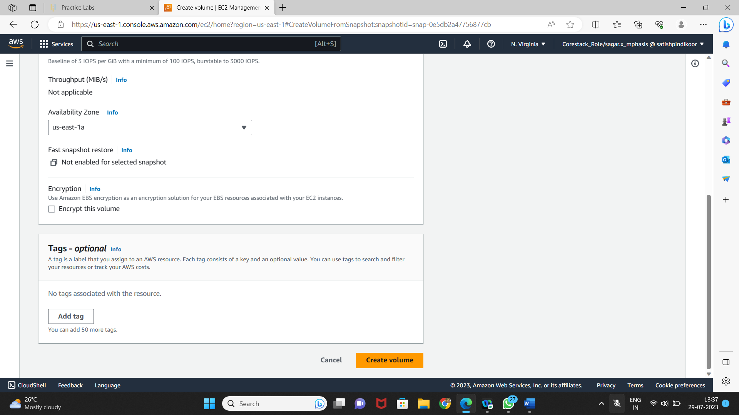

* Restore the volume from the snapshot

